# Lab: Simple To do list in ASP.NET MVC

# Simple “To Do List”

If you successfully complete all steps, you will have “To Do List” application with the following functionality:

* **Add Item** – adds an item to the list. It should look like this:

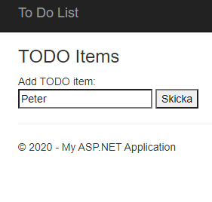 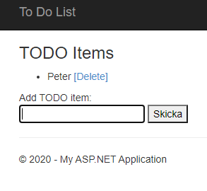

* **Remove Item** – removes the item from the list. It should look like this:

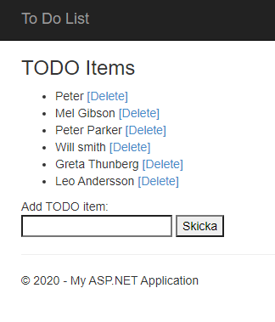 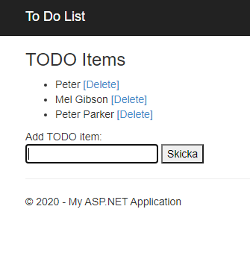

It should also keep your data if you exit the site (not the browser) and come back later.

## Create New Project

Let’s create new ASP.NET Project.

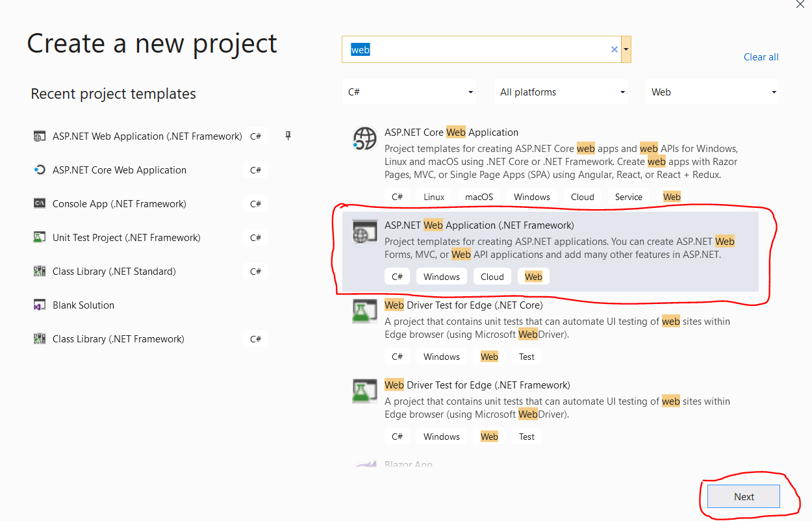

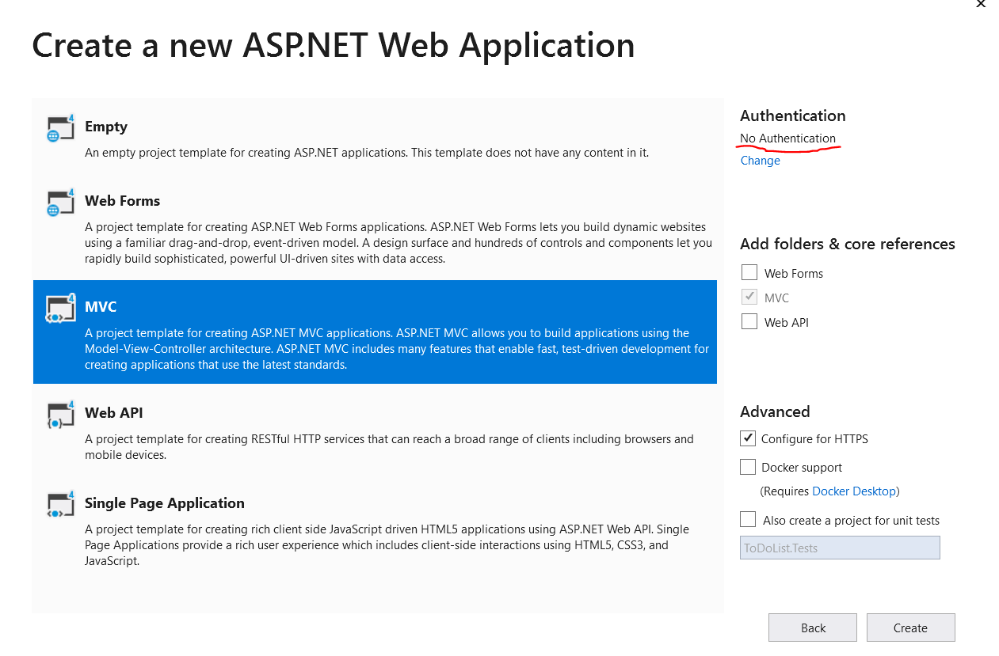

Change the authentication to “**No Authentication**”. Click OK, and you are done with this part.

Now we should delete the unnecessary files:

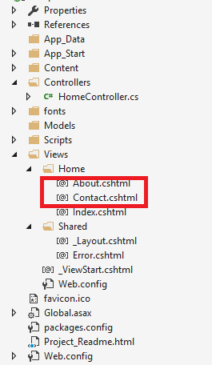

We will work with only 3 files to achieve our project:

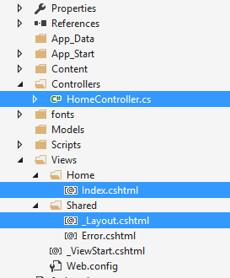

_Layout.cshtml – We have our main template/layout for the application

Index.cshtml – The main (and only) page in our site

HomeController.cs – We will create our application logic in that file.

## Edit the Layout

We will edit our _Layout.cshtml now. Let’s make those changes:

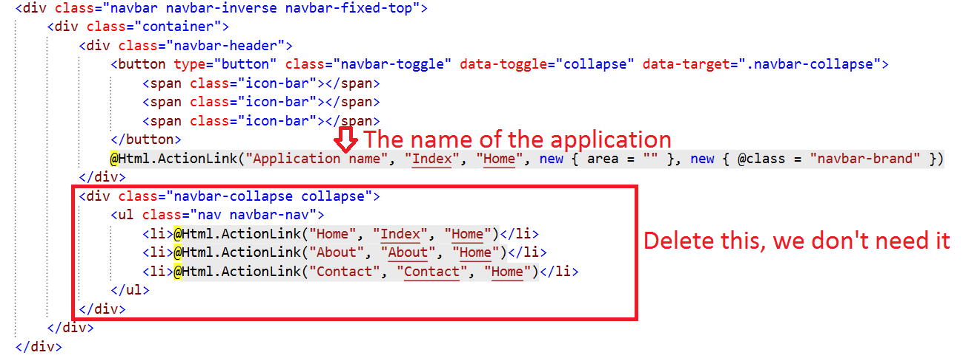

We don’t need navigation menu, so we can delete the div that creates it. The only thing left to change is to rename our application. We should have something like this:

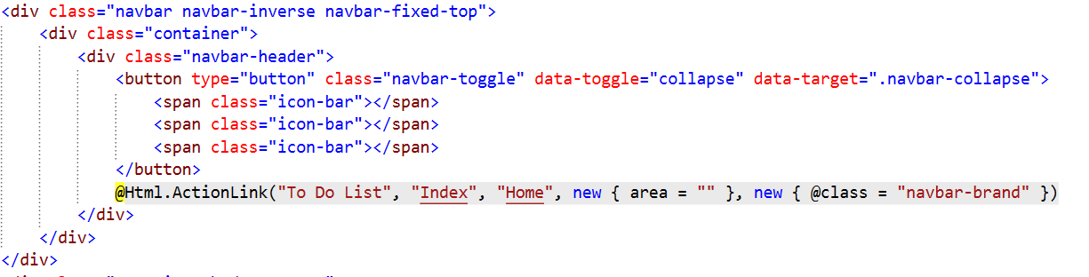

If we **start the application**, we should see this:

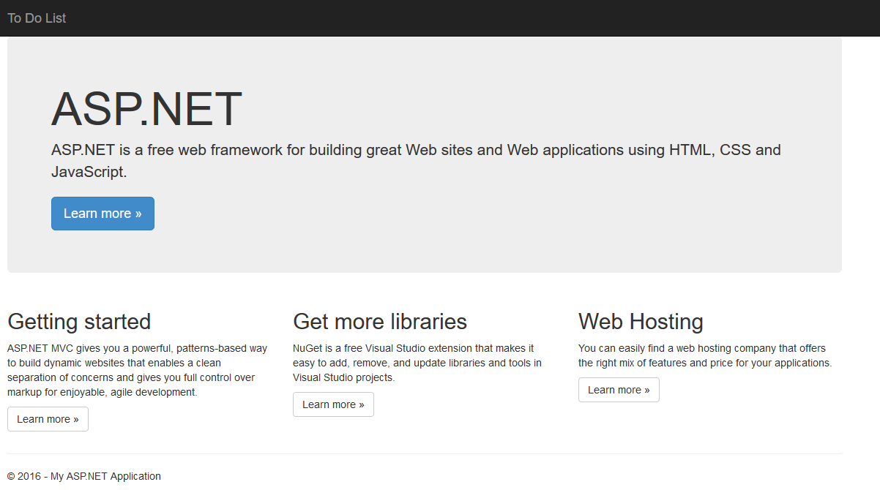

You can **edit the footer** in the same file, it shouldn’t be that hard.

## Edit the Main Page

Our file for this step is index.cshtml. You should see bunch of stuff, but don’t worry, we will delete everything except for this part:

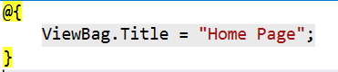

While you’re at it, **change the Title** to “To Do List”. Now we should **create a simple HTML form** like this one:

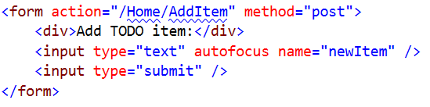

This form will add items to our list by **calling a method** in the HomeController.cs. Don’t worry for that now, let’s see what we have now:

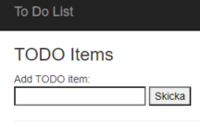

Not bad, but we have more work to do. Before we show the contents of the list, we have to edit the controller.

## Edit the Controller

Go to HomeController.cs. You should see something like this:

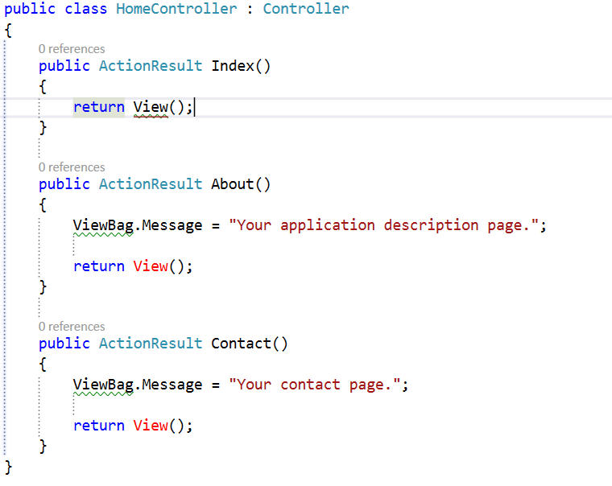

Delete the About() and Contact() methods. We don’t need them. Now we have only our Index() method.

We need to do slight adjustments to it. First we need to **get the list** from the browsers **session** (we will keep it there), and if there is nothing in there, we should **create a new list**. Then we need to **pass this list to the view**, so it can **render** **it**.

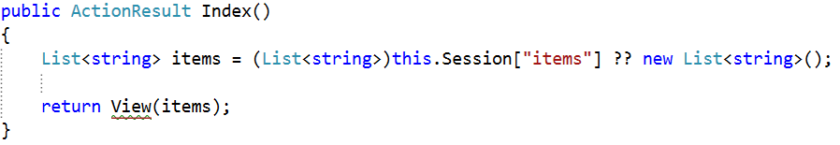

You can check the ‘??’ operator in google. It’s called **null-coalescing operator**. **If the left part is null**, it **returns** the **right** **part**.

Now we need to **write a simple method** that **adds** our **items** from the **textbox** to **our** **list**:

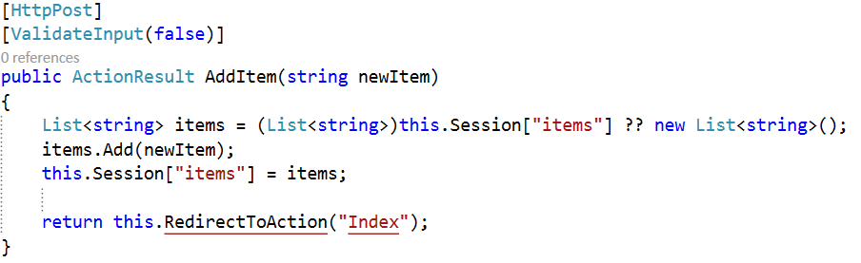

## Print the List

Now we should go back to the Index.cshtml and print the list, using single for loop. Write this code **above** our HTML form:

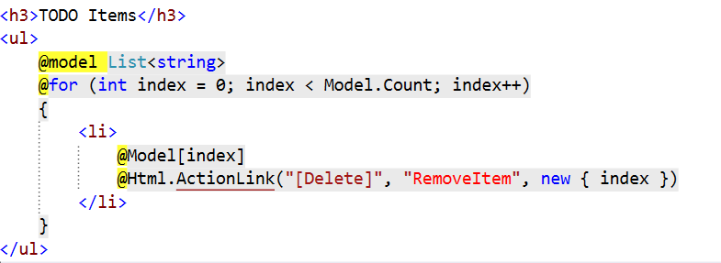

What we do here? First we get our list and start a for loop that will print our items. For each item, we add ActionLink to it, which will later help with deleting the item. It basically **binds a hyperlink to a method** in our **controller**. The last parameter is the **index of the element** that this link will delete. It’s complicated, but you will get used to it, don’t worry. We are done with this file.

## Delete from the List

The last thing we need to do is to create a method that **deletes an item** from the list. As you probably already know, we will do that in the HomeController.cs. Let’s write the following method:

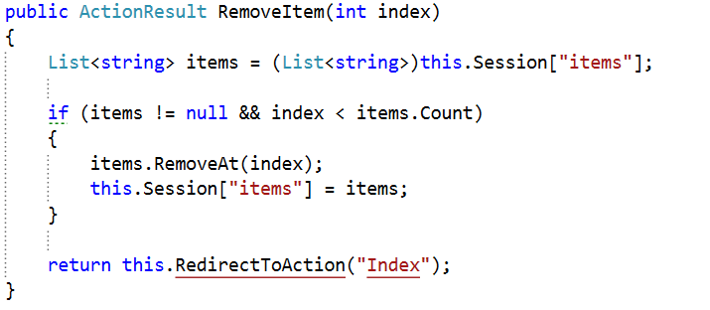

This method gets our list. If the **list exists** and the **index is less than** the **count** ofitems, it removes the element. **You should** **add** a **validation** that **checks** if the index is **more than zero**.

That is everything! Now you should fully functional application, like the one on the pictures in the beginning.